Monday | Tuesday | Wednesday | Thursday | Friday
3. Today we will be learning about baby farm animals. | 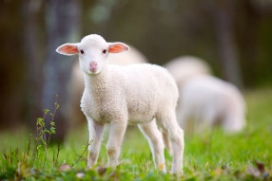 | 5. Let’s make Easter nest cakes. | 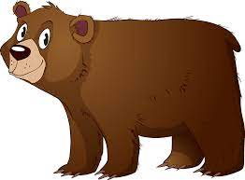 | 7. Good Friday. Nursery is closed today.
10. Easter Monday. Nursery is closed today. |  | 12. Parent Easter egg hunt. 5.00-5.30pm.  (see poster) | 13. Today the children will be taking part in an egg and spoon race. | 14. Homework Challenge!  Egg Competition.  (see poster)
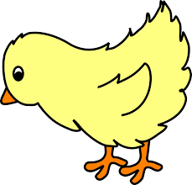 | 18. Let’s learn about the chick lifecycle. | 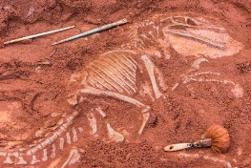 | 20. Let’s do a dinosaur dig and make fossils.
24. Lets make Spring rainbows |  | 26. Sports Day with parents. Come and join us! 4.30-5.00pm |  | 28.  Flower observational painting.

