Monday | Tuesday | Wednesday | Thursday | Friday
 |  |  | 1. Global Day of Parents! Today we will be creating our own family tree crafts. | 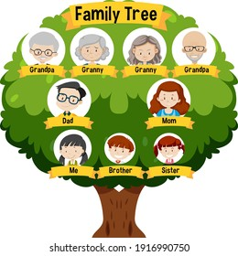
5. Today we will be making our own veggie rolls | 6. Let’s make Father’s Day cards and gifts. |  | 8. World Ocean Day!  Today we will be making our own ocean collages. | 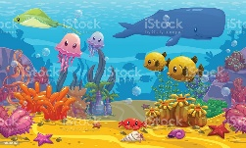
12. Heathy Eating Week! Today we will be making our own smoothies | 13. Today we will be making our own fruit salad. | 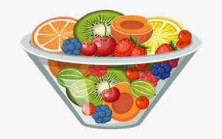 | 15. Today we will be exploring different textures and making collages | 16. Today we will be making chocolate puff pastries.
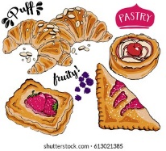 | 20. Come and join us for our sensory stay and play.  4.00-5.00pm. | 21. Let’s use explore colours and marks by using paint sticks. |  | 23. Today we will be exploring ice and scoops (empting and filling).
26. Today we will be exploring frozen fruit. | 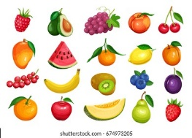 | 28. Today we will be using fruit in paint to mark make. | 29. Today we will be going on a sensory walk in the garden. | 