Monday | Tuesday | Wednesday | Thursday | Friday
 |  |  | 1. Dinosaur Day!  Today we will be exploring a sensory dinosaur swamp looking at big and small. | 2. Today we will be exploring salt dough and making our own dinosaur fossils.
5. Let’s make Father’s Day cards and gifts. | 6. Today we will be making our own traffic light biscuits. | 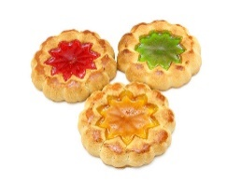 | 8. World Ocean Day!  Today we will be making our own ocean sensory bottles. | 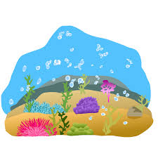
12. Heathy Eating Week! | 13. Today we will be tasting different fruits. | 14. Today we will be using different fruits in paint to mark make. | 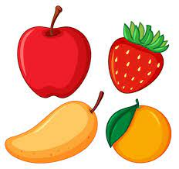 | 16. Today we will be exploring frozen fruit.
 | 20. Today we will be taking part in different physical activities in the garden. | 21. Stay and Play!  Come and join us for a picnic in the garden.  4:00-5:00pm. |  | 23. Today we will be going on a bug hunt in the garden.
26. Today we will be creating summer pictures. |  | 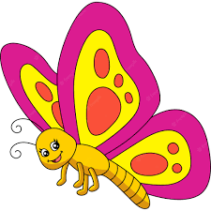 | 29. Today we will be creating symmetry butterfly crafts.

