Monday | Tuesday | Wednesday | Thursday | Friday
1. May Day.  Nursery will be closed today. | 2. Hedgehog Awareness Week. Today we will be making hedgehog pictures. | 3. Today we will be making hedgehog baked bread. | 4. Today We will be painting lanterns and making our own planets. | 5. Cinco de Mayo (Mexican celebration). Today we will be making vegetable fajita’s and dancing to festival music.
8. Bank Holiday!  Nursery will be closed today. | 9. Today we will be exploring a garden themed tuff tray. | 10. Today we will be exploring flowers frozen in ice. |  | 12. Today we will be roleplayimg being nurses.
15. International Day of Families. Today we will be creating family tree pictures. Can you please bring in some family photos? | 16. National Vegetarian Week. Today we will be making vegetable curry. | 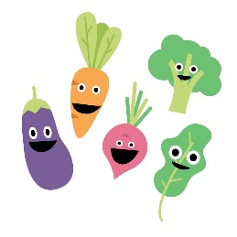 | 18. Today we will be mark making with different vegetables. | 19. Today we will be planting our own vegetables in the garden.
 | 23. Today we will be making our own  binoculars with tubes. The children will use these to go on their scavenger hunt tomorrow. | 24. National Scavenger Hunt Day! Today we will be going on a scavenger hunt in the garden. |  | 26. Today we will be making pictures using what we have found on our Scavenger hunt.
29. Bank Holiday!  Nursery is closed today. |  | 31. Today we will be exploring fruits froze in ice.

