Monday | Tuesday | Wednesday | Thursday | Friday
1. May Day.  Nursery will be closed today. | 2. Hedgehog Awareness Week. Today we will be learning all about hedgehog’s and making our own fact files. | 3. Cinco de Mayo party!  Come and join us at our party stay and play.  (see poster) | 4. Today we will be making sausage rolls. | 5. Cinco de Mayo (Mexican celebration).  Today we will be learning all about Cinco de Mayo.
8. Bank Holiday.  Nursery will be closed today. | 9. Today we will be learning all about E-Safety and taking parts in E-safety activities. |  | 11. Come and join us for our Forrest School stay and play. (see poster) | 12. Today we will be making chocolate brownies.
15. Today we will be making our own summer collages | 16. National Vegetarian Week. Today we will be making vegetable soup. | 17. Today we are having a school readiness workshop.  Come and join us 7pm-8pm. |  | 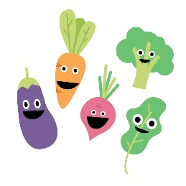
 | 23. PE Day! Come to nursery dressed in sports clothes. We will be taking part in lots of physical activities. |  | 25. Today we will be planting our own sunflower seeds.
29. Bank Holiday.  Nursery will be closed today. | 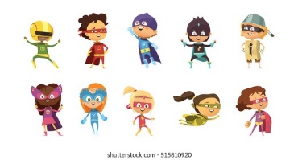 | 31. Today we will be learning about the life cycle of flowers

