Monday | Tuesday | Wednesday | Thursday | Friday
 |  |  | 1. Today we will be learning all about summer. | 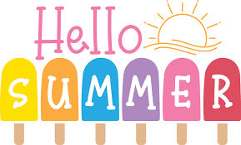
5. Today we will be learning all about sun safety |  | 7. Let’s make Father’s Day cards and gifts. | 8. World Ocean Day!  Today we will be creating our own ocean fact files. | 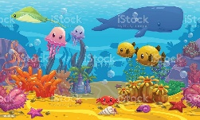
12. Heathy Eating Week! | 13. Today we will be learning all about heathy eating. | 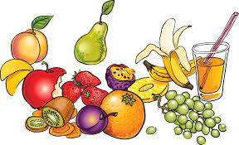 | 15. Today we will be making our own fruit lollies. | 16. Today we will be learning about the different vegetables that we are growing.
19. Come and join us for our Super worm stay and play.  4.00-5.00pm. | 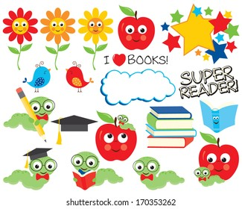 | 21. Today we will be exploring different countries and their cultures. | 22. Today we will be making our own pizza swirls. | 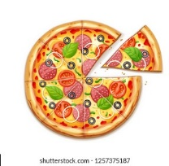
26. Today we will be making cookies. | 27. Today we will be having a phonics themed day. | 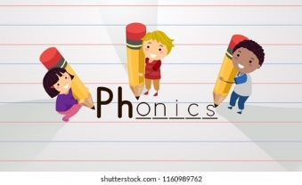 | 29. Today we will be taking part in different physical activities and having races. | 