Monday | Tuesday | Wednesday | Thursday | Friday
 |  |  | 1. Dinosaur Day. Today we will be doing lots of dinosaur themed activities. | 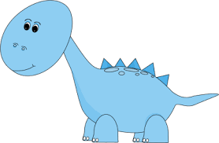
 | 6. Today we will be creating butterfly pictures, using line of symmetry. | 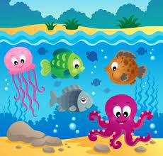 | 8. World Ocean Day. Today we will be creating our own ocean pictures and exploring an ocean tuff tray. | 9. Today we will be having a teddy bears picnic in the garden for tea.
12. Healthy Eating Week. Today we will be chopping our own healthy fruits to make fruit kebabs for snack. |  | 14. Today we will be making Father’s Day cards and crafts. |  | 16. Come and join us for our Father’s Day Stay & Play in the garden from 4:30-5:30pm.
 | 20. Today we will be making frozen fruit lollies. | 21. World Music Day. Today we will be listening to different instruments sounds, playing them and making our own. |  | 23. Today we will be exploring different coloured ice and using scoops to count in the water tray.
26. Today we will be creating different jungle animal crafts and moving like jungle animals in different ways. | 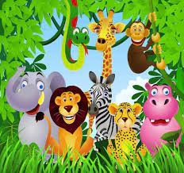 | 28. Today we will be creating our own self-portraits and looking at our facial features. | 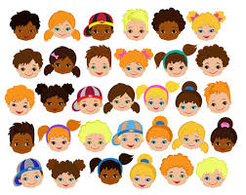 | 30. We hope you have enjoyed this month’s events, look out for our July calendar coming soon.

