Monday | Tuesday | Wednesday | Thursday | Friday
1. Bank Holiday.  Nursery is closed today. |  | 3. Today we will be making Mexican Tacos in cooking club. |  | 5. Today we will be making crowns and Union Jack flags.
8. Bank Holiday.  Nursery is closed today. | 9. Today we will be learning about sun safety. |  |  | 12. National Nurses Day. Today we will be roleplaying doctors and nurses.
15. International Day of Families. Today we will be talking about our families and looking at similarities and differences with family photos. | 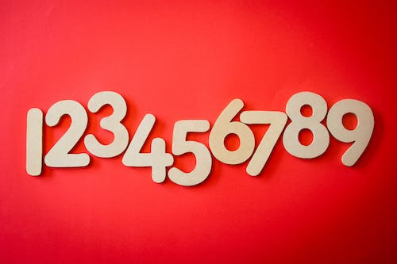 | 17. National Numeracy Day. Today we will be exploring numbers in the garden. | 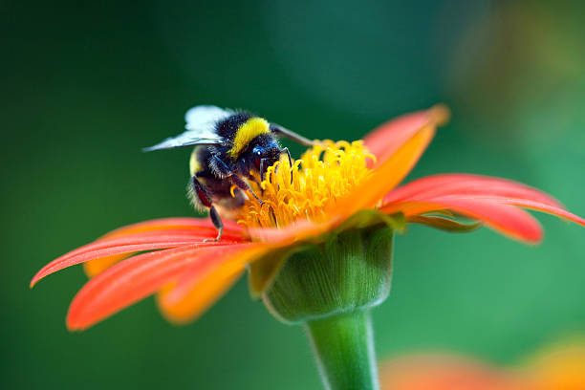 | 19. World Bee Day is tomorrow. Today we will be learning about how Bee’s help our environment.
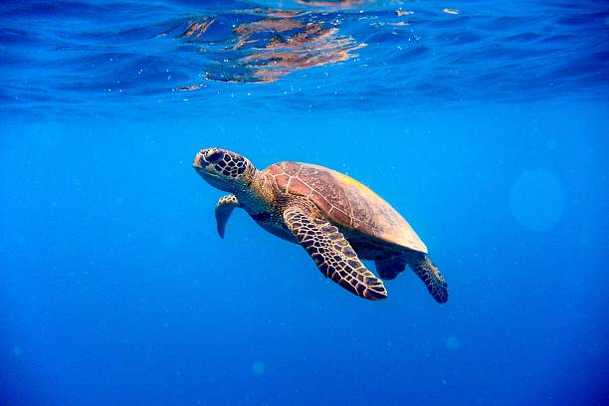 | 23. Today we will be exploring a turtle tuff tray. |  | 25. Africa Day today. We will be making our own African flags and learning about their culture. | 26. Today is Elmer Day. We are going to be exploring the story and creating our own colourful Elmer elephants.
29. Bank Holiday. Nursery is closed today. |  | 31. We hope you have enjoyed this month’s activities. Look out for June’s calendar coming soon.

