Monday | Tuesday | Wednesday | Thursday | Friday
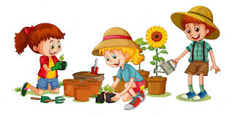 | 4. Let’s explore a gardening tuff tray with pots, tools, soil and flowers. | 5. Today we will be creating our own postcards. | 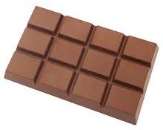 | 7. Let’s make vegan chocolate milkshake for World Chocolate Day.
10. Let’s explore frozen flowers in a tuff tray. | 11. Let’s make sunshine wands. |  | 13. Today we will be exploring sharks in the water tray and painting our own sharks. | 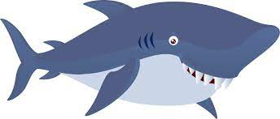
17. Today we will be mark making with fruit and vegetables and exploring different colours. | 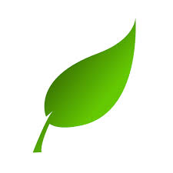 | 19. Today we will be creating a nature collage with natural resources from the garden. | 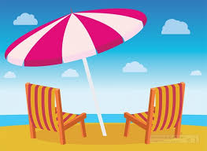 | 21. Today we will be exploring a beach themed tuff tray and learning the names of things you find at the beach.
 | 25. Let’s make fruity ice lollies. | 26. Today we will be making bubble wrap star fish. | 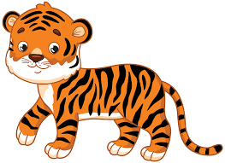 | 28. Tiger Day! Come to nursery dressed in Tiger stripes. We will be creating our own Tiger faces with paper plates.
31. Today we will be creating our own sensory bags.

