Monday | Tuesday | Wednesday | Thursday | Friday
3. American Independence Day!  Today we will be making flags. | 4. Today we will be learning about America and their celebrations of 4th July. |  | 6. Come and join us for our Amercan stay and and play.  (see poster for details) | 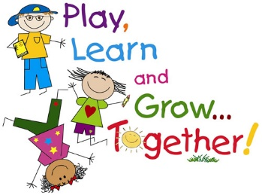
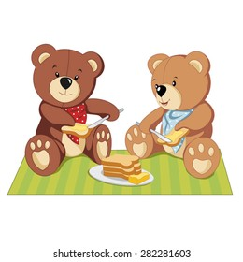 | 11. Teddy Bears Picnic! We will be making our own sandwiches. |  | 13. Today we will be making goodbye cards for our friends. | 14. Today we will be having a leavers disco. Parents and siblings are welcome.  (see poster for details)
17. Today we will be learning about different countries. | 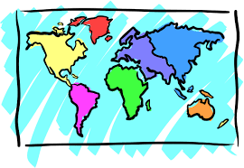 | 19. Today we will be creating different people from around the world. |  | 21. Today we will be trying different culture foods.
24. Today we will be drawing our favourite nursery memory. |  | 26. Princess and Superhero Day. Come dressed up as your favourite character. | 27. Today we will be having a maths themed day. We will be taking part in lots of fun activities. | 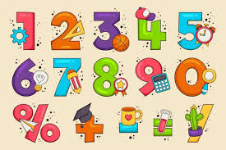
31. We hope you have had a lovely weekend!

