Monday | Tuesday | Wednesday | Thursday | Friday
3. Let’s make rainbow pictures and explore colours for Pride. |  | 5. Today we will be exploring different coloured ice in a tray with different sized scoops. | 6. Today we will be making fruit smoothies.
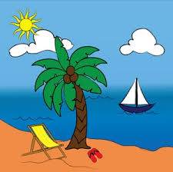 | 11. Today we will be exploring a beach tuff tray. | 12. Today we will be making our own beach scene pictures. |  | 14. Today we will be making sun catchers in the garden.
17. National Ice-cream Day. Today we will be exploring shaving foam and paint to role-play making our own ice cream. |  | 19. Today we will be making ice-cream crafts. | 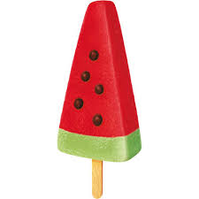 | 21. Today we will be making watermelon ice-lollies. We will chop and blend the fruit and then pour it into watermelon shaped moulds.
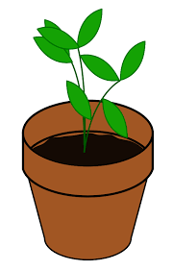 | 25. Today we will be planting cress seeds and watching them grow. | 26. Today we will be going on a sensory walk around the garden to see what we can smell, touch, see and hear. | 27. Today we will be creating under the sea themed sensory bags. | 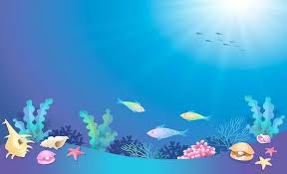
31. We hope you have enjoyed this month’s events and activities.

