Monday | Tuesday | Wednesday | Thursday | Friday
 | 4. American Independence Day!  Today we will be exploring red white and blue themed activities. |  | 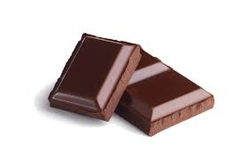 | 7. World Chocolate Day! Today we will be making hedgehog cakes.
10. Today we will using natural resources in the garden to make marks in paint on a large scale. | 11. Today we will be having a teddy bears picnic in the garden.  Bring in your favourite teddy and join us in the garden. 4:00-5:00. | 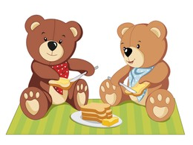 | 13. Today we will be mark making using frozen colours ice sticks. | 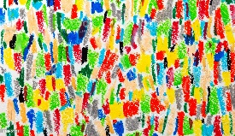
17. World Emoji Day!  Today we will be making our own emoji sensory balls using balloons and flour. |  | 19. Today we will be making our own sensory music shakers. | 20. Today we will be making our own yoghurt ice-lollies
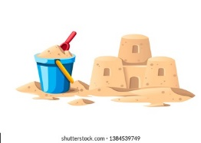 | 25. Today we will be using different mark making tool to mark make in sand. | 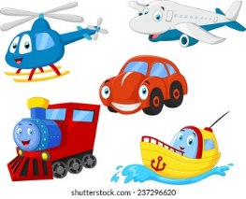 | 27. Today we will be using transport in paint to create our own pictures. | 28. Today we will be making sock puppets.

