Monday | Tuesday | Wednesday | Thursday | Friday
 | 1. Today we will be exploring frozen watermelon. | 2. Today we will be making watermelon ice-lollies. | 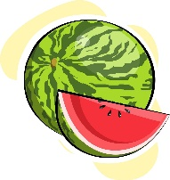 | 4. Today we will be exploring rainbow coloured ice cubes.
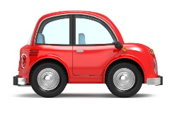 | 8. Today we will be using cars in coloured paint to make marks/car tracks. | 9. Today we will be mark making using different vegetables in paint. | 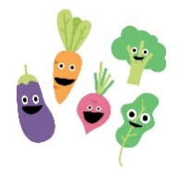 | 11. Today we will be taking part in a mini obstacle course.
14. Today we will be using utensils in paint to experiment with colours and marks. |  | 16. Today we will be making our own shakers to make music and sing rhymes. | 17. Come and join us for our animal themed stay and play. 4-5pm. | 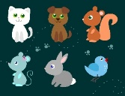
21. Today we will be exploring with the textured sensory balls and different sized tubes to roll the ball through. | 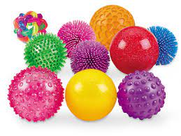 | 23. Today we will be exploring a trifle tuff tray. |  | 25. Today we will be using different sized tubes as tunnels for the children to explore and push different transport through/down.
28. Bank Holiday!  Nursery will be closed today. | 29. Today we will be making strawberry milkshakes. |  | 31. Today we will be using pine cones in paint to create pictures. | 