Monday | Tuesday | Wednesday | Thursday | Friday
 | 1. Today we will be exploring the colour yellow. | 2. Today we will be sponge painting making watermelons. | 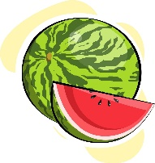 | 4. Owl Awareness Day! Let’s make own crafts.
7. Today we will be exploring jelly in different colours. | 8. Today we will be ice printing exploring colours and marks. | 9. Today we will be reading the Dear Zoo story and exploring activities around this. | 10. World Lion Day!  Let’s make lion crafts. | 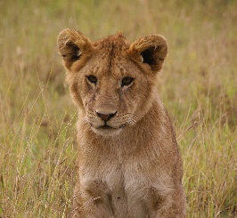
14. Today we will be using shapes to create monster pictures. | 15. Today we will be bubble wrap printing in paint. | 16. Today we will be making sensory bottles. | 17. Number Hunt!  Let’s find hidden numbers in gellibaff | 18. Today we will using utensils in paint to experiment with colours and marks.
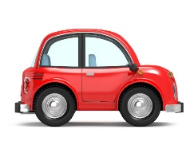 | 22. Today we will be washing cars outside. | 23. Today we will be making pasta bracelets. | 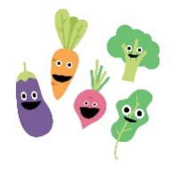 | 25. Today we will be exploring a planting tuff tray. (planting vegetables)
28. Bank Holiday!  Nursery will be closed today. |  | 30. Today we will be making pizza. | 31. Today we will be making fruit smoothies.

