Monday | Tuesday | Wednesday | Thursday | Friday
 | 1. Let’s create beach pictures |  | 3. Today we will be making our own dinosaur fossils. | 4. Don’t forget to take home your homework packs.
7. Let’s make watermelon ice-lollies. |  | 9. Today we will be making boats and having boat races. | 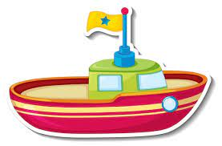 | 11. Can you make a fruity milkshake at home? Please send in pictures to share.
14. Today we will be making sun catchers. |  | 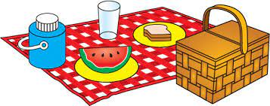  16. Come and join us for our picnic stay and play. (see poster) | 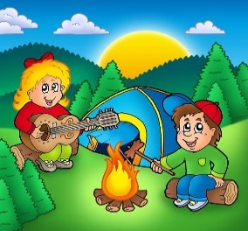 | 18. Today we will be roleplaying a campfire in the nursery garden.
 | 22. Today we will be role-playing an ice-cream shop | 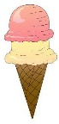 | 24. Let’s make coloured ice and look at how it melts. | 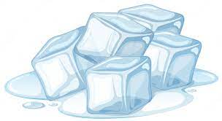
28. Bank Holiday!  Nursery will be closed today. |  | 30. Today we will be making our own fruit juice. | 31. Today we will be making fans to keep us cool.

