Monday | Tuesday | Wednesday | Thursday | Friday
 | 1. Today we will be having a teddy bears tea party in the garden. | 2. Today we will be making our own healthy sandwiches in cooking club. | 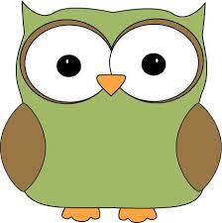 | 4. Owl Awareness Day! Today we will be creating our own owl crafts and learning different facts.
7. Today we will be exploring jungle animals in ice, using hammers to break them free. | 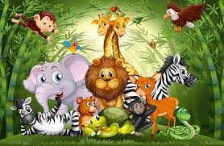 | 9. Today we will be hunting for dinosaurs in the garden using magnifying glasses and a checklist. | 10. World Lion Day. Today we will be moving around like lions and making our own Lion masks. | 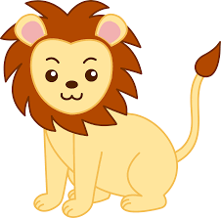
 | 15. Indian Independence Day. Today we will be creating flags and trying some different Indian foods. | 16. Today we will be having a car wash in the garden using large sponges and buckets of soapy water. |  | 18. Today we will be making pizza in cooking club.
21. Today we will be exploring blue Jelly Bath with boats and sea animals. |  | 23. Today we will be using spray bottles with paint to make splash marks on paper, exploring different colours. |  | 25. Today we will be looking at similarities and differences between our friends and family.
28. Summer Bank holiday. Nursery is closed today. | 29. Today we will be making sun catchers. |  | 31st - We hope you have enjoyed this month’s events and activities, look out for the next one.

