Monday | Tuesday | Wednesday | Thursday | Friday
 |  |  |  | 1. Today we will be using leaves in paint to create our own pictures.
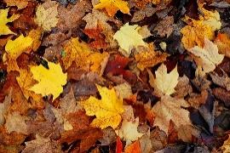 | 5. Today we will be using leaves to make a collage. | 6. Read a Book Day!  Bring your favourite story to read and share with your friends. |  | 8. Teddy Bear Picnic!  Today we will be having a picnic with the teddy bears.
11. Today we will be making Autumn trees using paint and sticks. | 12. Today we will be making light up lanterns. | 13. Today we will be making pumpkin spiced pies. |  | 15. Let's make salt dough leaves today.
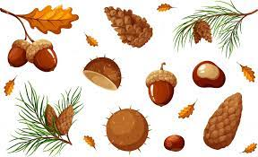 | 19. Let’s explore pine cones and acorns in the water. | 20. Come to the nursery dressed in sports clothes to celebrate Fitness Day. We will be taking part in different physical activities. | 21. Today we will be making sun catchers
25. Today we will be making pirate hats. |  | 27. Today we will be making sensory collages |  | 29. World Heart Day!  Today we will be making heart crafts for heart day.

