Monday | Tuesday | Wednesday | Thursday | Friday
 |  |  | 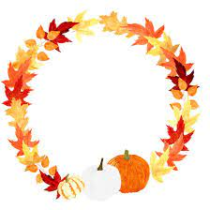 | 1. Today is the start of Autumn. We will be making Autumn wreaths.
4. Today we will be exploring colours and marks using conkers in paint. |  | 6. Read a Book Day!  Come and join us and read the Gruffalo story and take part in story themed activities.  4.30-5.00 | 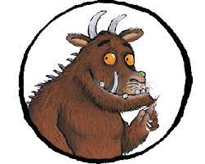 | 8. Teddy Bear Picnic!  Today we will be having a picnic with the teddy bears.
11. Today we will be using natural resources in the garden to create our own leaf crafts. | 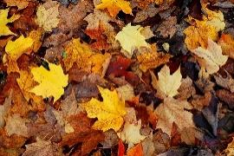 | 13. Today we will be exploring orange moon sand. | Today we will be using forks in paint to create Hedgehog pictures. | 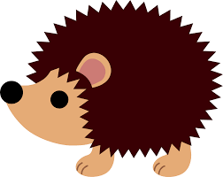
18. Today we will be using apples in paint to create marks and explore colours. | 19. Pirate Day!  Today we will be going on a pirate adventure in the garden. |  | 21. Today we will be making pirate crafts.
25. Today we will be looking for different sized sticks in the garden and exploring big and small. The children will then use them in paint to create marks and explore colours. | 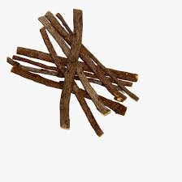 | 27. Today we will be making our own scarecrows. | 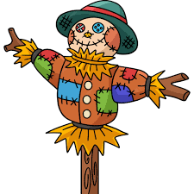 | 29. Today we will be making Autumn leaf sun catchers.

