Monday | Tuesday | Wednesday | Thursday | Friday
1. National Food Bank.
Let’s help those in need.
4. Today we will be learning all about Autumn. | 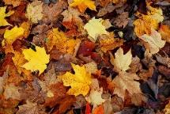 | 6. Today we will be going on an Autumn object hunt in the garden. Let’s count what we find. |  | 8. Let us learn all about what the emergency services do.
11. Today we will be learning about autumn animals | 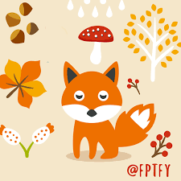 | 13. Positive Thinking Day! Let’s make positive jars. | 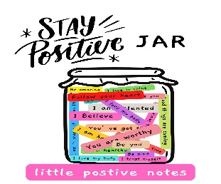 | 15. Today we will be using natural resources from outdoors to create faces.
 | 19. Pirate Day!  Today we will be going on a pirate adventure in the garden. | 20. Autumn stay and play! Come and join us for hot chocolate and marshmallows. |  | 22. Today we will be making sun catchers using natural resources outdoors.
25. World Dream Day!  Let's make dream catchers. |  | 27. Can you make a scarecrow at home and bring it to the nursery to share with you friends?  Winner will win a prize! |  | 29. World Heart Day! Let’s learn about the heart and how it works.

