Monday | Tuesday | Wednesday | Thursday |  | Friday
 |  |  | 1. We will be creating our own winter wonderland pictures.
5. Making winter sensory bags. |  | 7. Today we are using pom poms to create snow ball pictures. | 8. Today we will be wearing our Christmas jumpers |  | 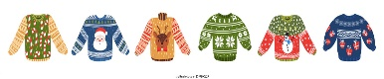
12. Let’s go on a walk to collect branches. |  | 14. With the branches we have collected we will create our own winter trees. |  |  | 16. Lets make our own Christmas hats for Christmas Hat Day.
19. Don’t forget your Home Observations. | 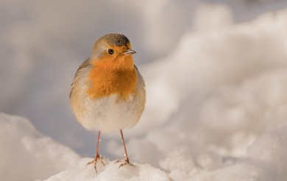 | 21. Let’s make our own Robin’s for National Robin Day. | 22. Making Christmas crafts. |  | 23. Have a lovely Christmas!
26. Bank Holiday. Nursery is closed. | 27. Bank Holiday. Nursery is closed. | 28. Today we will be learning about the New Year. |  | 30. Lets make New Years Eve pictures.

