Monday | Tuesday | Wednesday | Thursday |  | Friday
 |  |  | 1. Let’s decorate our Christmas tree. |  | 2. Today we will be meeting Elf on the Shelf.
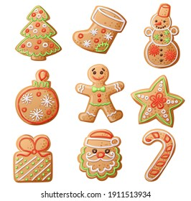 | 6. Today we will be making melted snowman biscuits. | 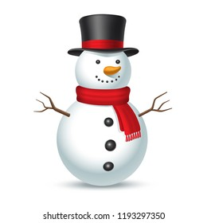 | 8. Today we will be wearing our Christmas jumpers. |  | 9. Today we will be making our own Winter Snowman.
12. We will be reading the story ‘Dear Santa’. | 13. We will be creating gifts for our friends and wrapping them. | 14. We will be writing our own Christmas lists for Santa. | 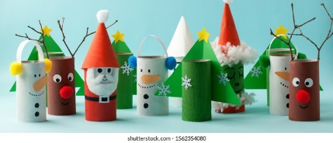 |  | 16. Today we will go on a walk to see the Christmas lights.
19. Today we will be reading the Christmas story. | 20. Today we make Christmas cornflake wreaths. |  | 22. We will be taking a visit to the local Church.
26. Bank Holiday. Nursery is closed. | 27. Bank Holiday. Nursery is closed. | 28. Today we will be learning about the New year. |  | 30. We will be making our own New years resolutions

