Monday | Tuesday | Wednesday | Thursday | Friday
2. Bank Holiday. Nursery is closed today.  Happy New Year! | 3. Can you bring in/email in some photos of your break to share with the group? | 4. Today we will be making our own Winter crafts. |  | 6. Today we will be making snowball rice crispie treats.
9. Don’t forget to bring in your home observations. | 10. Today we will be doing some salt painting to make our own snowflakes. |  | 12. Today we will be making our own Polar Bear crafts.
16. Today we will be looking at our winter clothing. | 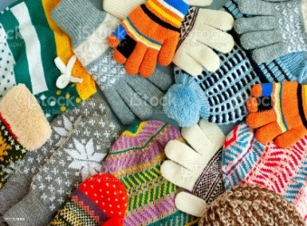 | 18. Winnie the Pooh day! Let’s make honey flapjacks. | 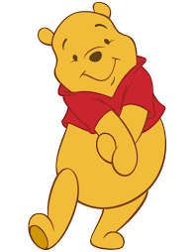 | 20. Let’s celebrate chinese new year! Come to nursery in your party clothes today.
23. Today we will be making Rabbit craft for the year of the rabbit. | 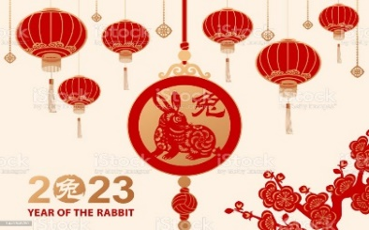 | 25. Don’t forget to vote your GEM. | 26. Australia Day! Come to nursery dressed in Red, White and Blue.
 | 31. Dress in black and white today for Zebra Day. We will be making Zebra Crafts!

