Monday | Tuesday | Wednesday | Thursday | Friday
2. Bank Holiday.  Nursery is closed today.  Happy New Year! | 3. Today we will be reading the story ‘How to Catch a Star’ and we will be making our own star biscuits. | 4. Today we will be exploring Light and Dark. |  | 6. Today we will be decorating our own stars.
9. Let’s read the book ‘Dear Zoo’. | 10. Today will be writing our own letters to the Zoo! | 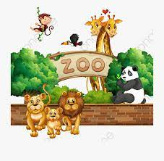 | 12. Today we will be making boxes for our animals. | 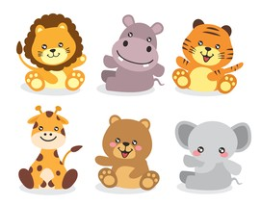
 | 17. Martin Luther King Day! Let’s learn about Martin Luther King! | 18. Today we will be trying Stir Fry. | 19. Today we will be exploring Rabbits. | 20. Chinese New Year! Let’s make our own lanterns.
23. Today we will be reading the book ‘Pants!’ | 24. Today we will make painted pants toast. | 25. Today we will be decorating our own pants! | 26. Today we will be changing the Home Corner into a clothes shop! | 27. Today we will be learning breathing techniques and taking part in some baby yoga.
30. National Story-telling Week. Today can you bring your favourite story into nursery. | 31. Today we will be planting magic beans.

