Monday | Tuesday | Wednesday | Thursday | Friday
 |  | 1. Bring in your favourite book | 2. Lets create our own story books. | 4. Today we will be making our own Yorkshire Puddings for British Yorkshire Pudding Day!
6. Children’s Mental Health Week. Let’s talk about our feelings. | 7. Lets explore salt painting. | 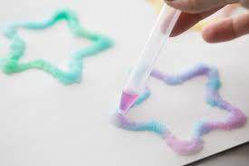 | 9. National Pizza Day!  Lets make pizzas. | 10. We shall be doing mindful yoga.
 | 14. Valentines Day! | 15. We will be baking jam tarts. | 16. School seadiness skill - put our own coats on. | 17. Random Acts of Kindness Day.
20. National Love Your Pet Day. Bring pictures of your pets into nursery to share with your friends. | 21. Pancake Day! Let’s make our own pancakes. | 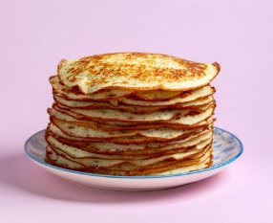 | 23. Lets go on a shape hunt. | 24. Lets do dough disco.
27. International Polar Bear Day. We will be learning all about Polar Bears.

