Monday | Tuesday | Wednesday | Thursday | Friday
 |  | 1. Today we will be tasting different beans. | 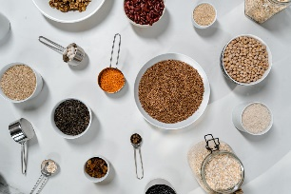 | 3. Today we will be creating our own beanstalks.
6. Today we will be reading the book Chocolate Cake. | 7. Today we will be making chocolate cake. |  | 9. Today we will be exploring melted chocolate. | 10. Teddy Day!  Bring your favourite teddy to Nursery.
13. Today we will be making Valentine’s Day cards. | 14. We will be baking heart shaped cookies. | 15. There will be a Valentines stay and play. 4:00 - 5:00pm. | 16. We will be decorating our own love hearts. | 17. We will be making love potions in the water tray.
20. Today we be reading Kitchen Disco. | 21. Today we will be making Banana Splits. | 22. Today we will be exploring healthy eating. | 23. Today we will be printing with fruit.
27. Let’s explore the moon. | 28. Today we will be making our own marbled moons.

