Monday | Tuesday | Wednesday | Thursday | Friday
3. Rainbow Day! Today we will be exploring Rainbow coloured spaghetti | 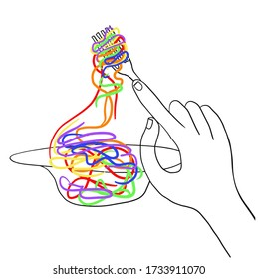 | 5. Easter Crafts |  | 7. Bank Holiday. Nursery is closed today.
10. Bank Holiday. Nursery is closed today. | 11. Today we will be exploring our reflections using mirrors. |  | 13. We will be exploring different fruits and vegetables | 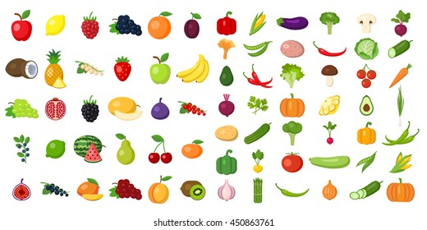
17. Please send in your photos of your weekend! | 18. We will be listening to the sounds of nature in the garden. | 19. Peek-a-boo games using different textures and materials. | 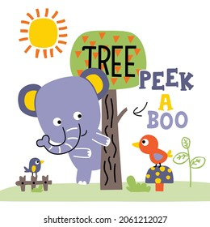 | 21. We will be having a construction themed day!
24. We will be making marks in gloop using cars. | 25. We will be exploring animals in different coloured sand. |  | 27. Exploring frozen objects in water play | 