Monday | Tuesday | Wednesday | Thursday | Friday
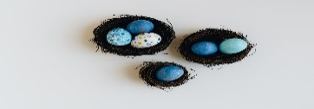 | 4. Let’s make Rice Krispie nests. | 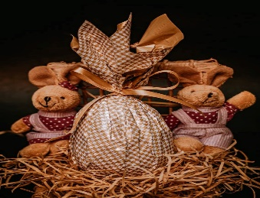 | 6. Let’s make Easter crafts. | 7. Bank Holiday. Nursery is closed today.
10. Bank Holiday. Nursery is closed today. | 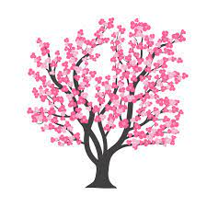 | 12. Making our own blossom trees. | 13. Lets make a picture for World Art Day.
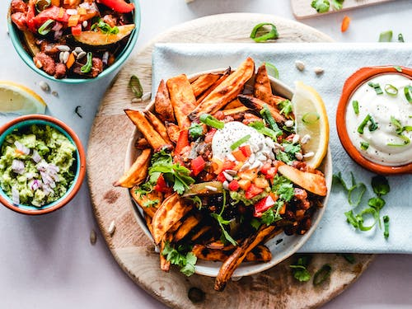 | 18. For World Heritage Day! We are looking at cultural foods. If you have a dish that you would like the children to try then please feel free. | 19. Making a vegetable curry. |  | 21. Eid al- fitr. Lets make crafts
24. Making England flags for St George’s day. | 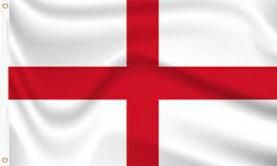 | 26. Don’t forget your home observations | 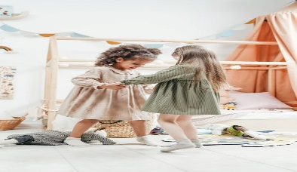 | 28. Lets look at how and why we recycle.

