Monday | Tuesday | Wednesday | Thursday | Friday
3. Today we will be learning about Easter. | 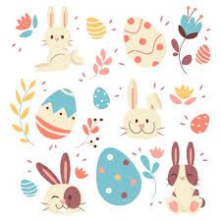 | 5. We will be making chocolate Rice Krispie cakes (Easter chocolate nests). | 6. Today we will be decorating our own Easter Eggs. | 7. Bank Holiday. Nursery is closed today.
10. Bank Holiday. Nursery is closed today. | 11. Today we will be making our own Supertato Story Spoons. | 12. Let’s try some different vegetables. | 13. Lets make our own superpotatoes | 14. Don’t forget your Home Observations.
17. Today we will be learning about Ramadan. | 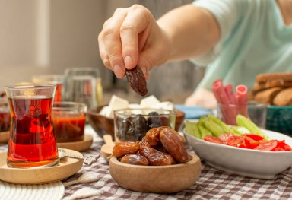 | 19. Today we will be tasting samosas. | 20. Today we will be making Eid cards. | 21. Eid-al-Fitar.
24. Today we will be reading the book ‘Stuck’. | 25. Penguin Day!  Today we will be making marshmallow penguins. | 26. Today we will be making our own fire engine. | 27. Today we will be making a wishing tree | 