Monday | Tuesday | Wednesday | Thursday | Friday
 |  | 1. St David’s Day. Come to nursery dressed in red white and green. | 2. World Book Day! Come to nursery dressed as your favourite book character.
6. Let’s explore healthy foods this week. |  | 8. Let’s taste different fruits and vegetables. | 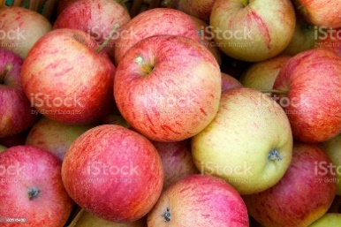 | 10. We will be making apple doughnuts.
13. We will be making clover biscuits for St Patrick’s Day. |  | 15. We will be creating St Patrick’s Day crafts. | 16. Come and join our Mother’s Day workshop  5-6pm. | 17. Red Nose Day!  Wear red to nursery.  Cake/ baking competition.
20. Don’t forget our Mothers Day Stay and Play. Afternoon tea/ spa  4-5:30pm. | 21. Wear odd socks for Downs Syndrome Day. | 22. World Water Day!  Let’s explore lots of different water activities. | 23. We will be exploring number rhymes for Maths Day.
27. Don’t forget to vote your GEM. | 28. Lets plant flowers ready for Spring. |  |  | 31. Rainbow crafts.

