Monday | Tuesday | Wednesday | Thursday | Friday
 |  | 1. St David’s Day. Let’s make daffodil biscuits. | 2. World Book Day! Come to nursery dressed as your favourite book character. | 3. Today we will design our own book covers.
6. We will be learning about Holi. | 7. Holi. Today we will be painting pictures using powder paints. | 8. Today we will be tasting Indian sweets. | 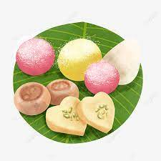 | 10. We will be exploring colour printing on a big roll of paper.
13. Today we will be reading “My Mummy is Magic” | 14. We will be exploring baby animals. | 15. Lets make our Mothers Day cards. | 16. Come and join our Mother’s Day Workshop. 5-6pm. | 17. Red Nose Day!  Wear red to nursery.
20. Don’t forget our Mothers Day Stay and play. Afternoon tea/ spa  4-5:30pm. | 21. International Colour Day. Today we will be creating a colour making tray. | 22. World Water Day!  Today we will be making lava lamps. | 23. Today we will be learning about Ramadan. | 24. Today we will be trying samosas.
27. Today we will be reading The Very Hungry Caterpillar. | 28. Lets plant flowers ready for Spring. | 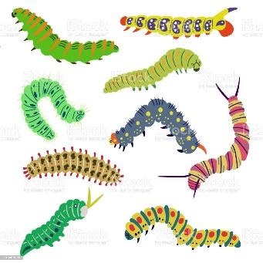 | 30. Today we will be making our own caterpillars cakes. | 