Monday | Tuesday | Wednesday | Thursday | Friday
 |  |  | 1.We are going to explore dinosaurs in a sensory tray. | 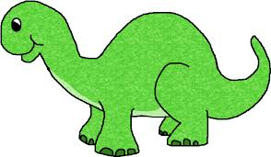
5. Environment Day!  We will be looking at the world around us. | 6. We will be using our toys to build objects. |  | 8. We will be exploring sea creatures for World Ocean Day! | 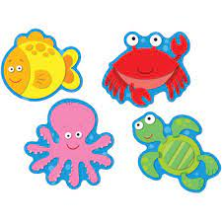
12. This week we will be exploring healthy foods for Healthy Eating Week. |  | 14. Today we will role play with different fruits and vegetables. | 15. We will be starting our Father’s day crafts. | 16. Come and join our Fathers Day stay and play. 4:30-6:00pm.
19. We will be exploring different insects for World Insect Day! | 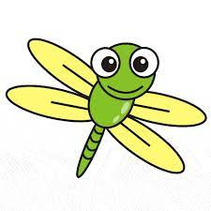 | 21. Music Day! We will be exploring different musical instruments. |  | 23. We will be in exploring in gloop.
26. Please bring your home observations from the weekend. | 27. We will be making Eid ul Adha cards. | 28. Lets make some frozen treats for Ice Lolly Day. | 29. We will be having an Eid celebration.

