Monday | Tuesday | Wednesday | Thursday | Friday
 |  |  | 1. Join us to celebrate our parents with some food. | 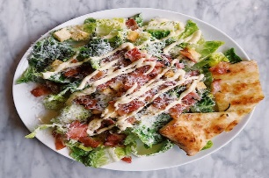
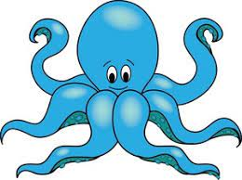 | 6. We will be making Octopus cakes. | 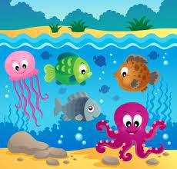 | 8. We will be exploring sea creatures for World Ocean Day! | 9. Please remember your Home Observations.
12. We will be making fruit potions today. | 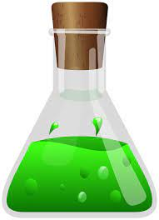 |  | 15. Let’s make Father’s Day crafts. | 16. Come and join our Fathers Day stay and play. 4:30-6:00pm.
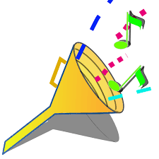 | 20. We will be exploring the sounds of different instruments. | 21. Lets make instruments for Music Day. | 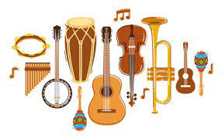 | 23. Don’t forget to vote for your GEM!
26. Lets make fruit ice lollies. |  | 28. Celebrate Eid with us! We will be doing some food tasting

