Monday | Tuesday | Wednesday | Thursday | Friday
 |  |  | 1. Dinosur Day. Let’s make dinosaur prints using paint. | 2. Today we will be making dino egg krispies.
5. World Environment Day! Let’s go on a litter pick. | 6. Today we are going to read the story Tiddler. | 7. Today we are going to make biscuits in the shape of a fish. | 8. World Ocean Day!  Lets make our own jelly fish. | 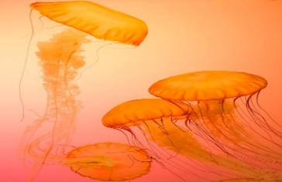
12. Superman Day. Come to nursery dressed as your favourite superhero. | 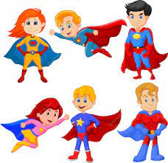 | 14. Lets paint with cars. | 15. Clean Air Day. Let’s explore transport. | 16. Come and join our Fathers Day stay and play. 4:30-600pm.
19. We hope you enjoyed your weekend! | 20. We will be reading Elmer the Patchwork Elephant. | 21. Today we will be painting a giant Elmer | 22. Today we will be making a rainbow fruit salad. | 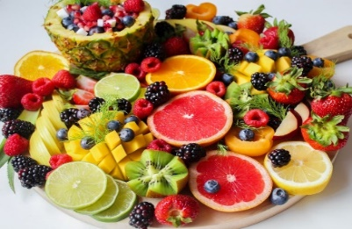
26. Lets create Eid crafts. | 27. Lets try flavoured rice | 28. Eid al Adah. Come to nursery dressed in sparkly clothes.

