Monday | Tuesday | Wednesday | Thursday | Friday
1. Bank Holiday.  Nursery is closed today. | 2. We will be making hedgehogs for Hedgehog Awareness. |  |  | 5. We will be making space biscuits for Space Day.
8. Bank Holiday.  Nursery is closed today. | 9. We will be making crafts to celebrate King Charles. |  | 11. Chalk printing.
15. International Family Day.  Join us for activities  4:30-5:30. |  | 17. Today we will be making bee hive crumpets. | 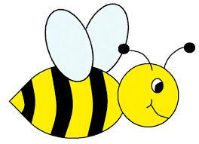 | 19. We will be making lots of bee crafts for World Bee Day.
22. Floral mark making. |  | 24. We will be making flower crafts. | 25. Today we will be making butterfly crafts. | 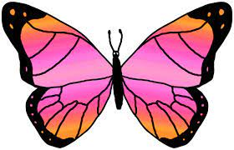
29. Spring Bank Holiday. Nursery is closed today. | 30. Lets plant our own cress. | 