Monday | Tuesday | Wednesday | Thursday | Friday
1. Bank Holiday.  Nursery is closed today. | 2. We will be making hedgehogs for Hedgehog Awareness. |  |  | 5. We will be making space biscuits for Space Day.
8. Bank Holiday.  Nursery is closed today. | 9. Lets make crafts to celebrate King Charles. |  | 11. Chalk printing.
15. Today we will be exploring farm animals in the tuff tray. | 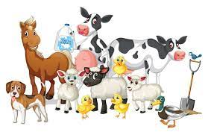 | 17. National Instruments Day. We will be exploring different insturments and songs. | 18. Parents Evening.  Make sure you book your appointments! | 19. Lets explore different messy activities.
22. We hope you all had a lovely weekend please bring in any photos. | 23. Let’s bake our own cookies. | 24. Fruit printing in paint. |  | 26. World Elmer Day!  We will be using different colours to create our own Elmer.
29. Spring Bank Holiday. Nursery is closed today. | 30. We hope you had a great Bank Holiday. | 31. Today we will be holding a food tasting session.

