Monday | Tuesday | Wednesday | Thursday | Friday
1. Bank Holiday.  Nursery is closed today. | 2. Let’s practice for Sports Day. | 3. Today we will exploring a colour changing flower experiment. | 4. Bird Day!  Lets go and find some birds outside. | 5. Lets celebrate the Kings Coronation. Stay and Play tea party, 4pm onwards.
8. Bank Holiday.  Nursery is closed today. | 9. World Plant Tris Day. Let’s explore this type of plant. | 10. Today we will be making a flower wreath to look at different types of flowers. | 11. Lets create sensory bottles. | 12. International Nurses Day!  Lets learn all about them.
15. School readiness skill  Use scissors safely | 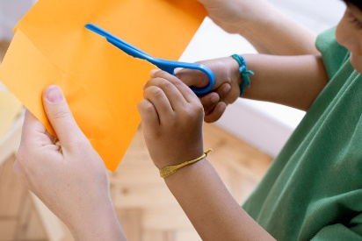 | 17. Numeracy Day!  Pre-School will be doing lots of numeracy activities. | 18. Let’s make rainbow toast. | 19. World Bee Day. Let’s learn about bees.
22. Lets do some fine motor q-tip painting. | 23. World Turtle Day. Let’s learn about and make our own turtles. | 24. Lets create our own wraps. |  | 27. Elmer Day.  Today we will read various Elmer stories.
29. Spring Bank Holiday. Nursery is closed today. | 30. National Biscuit Day. We will be making biscuits. | 31. World Otter Day. Let’s learn about otters in various ways.

