Monday | Tuesday | Wednesday | Thursday | Friday
1. Bank Holiday.  Nursery is closed today. | 2. Let’s read Rumble in the Jungle. | 3. World Laughter Day! Lets play some practical jokes. | 4. Lets paint our own animal masks. | 5. African World Heritage Day!  Lets make pasta necklaces.  Come and join our Coronation stay and play, 4pm onwards.
8. Bank Holiday.  Nursery is closed today. | 9. Lets make cheese and cucumber sandwiches. |  | 11. Eat What you Want Day! Lets make chocolate cake. | 12. Florence Nightingale’s birthday.  Lets turn the home corner into a hospital.
15. International Family Day. Bring in a picture of your family to share. | 16. National Smile Month. Let’s make paper plate smiles. | 17. Numeracy Day!  Lets go on a number hunt. | 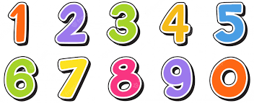 | 19. Hope you all have a lovely weekend!
22. Lets read the book Tiddler. | 23. World Turtle Day. Let’s make our own turtles. | 24. Lets make fish shaped pizzas. | 25. Lets make our own rock pool.
29. Spring Bank Holiday. Nursery is closed today. | 30. National Bus Day.  Let’s make our own bus stops.

