Monday | Tuesday | Wednesday | Thursday | Friday
 | 4. Come dressed in red, white and blue for American Independence Day. |  | 6. Mark making in chocolate. | 7. We will be making some yummy chocolate treats for World Chocolate Day!
10. Please do not forget your home observations from the weekend. | 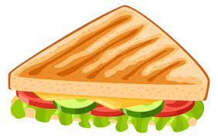 | 12. Lets make sandwiches. | 13. Come and join our picnic to celebrate Picnic Month.  4-5pm
17. Bring photos of what you have been up to on the weekend! | 18. Exploring different fruits. | 19. Lets explore fruity cubes. | 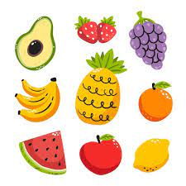 | 21. Don’t forget to vote your GEM.
24. Bring in photos of what you have been up to over the weekend. | 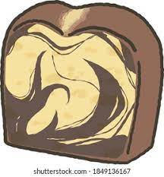 | 26. Lets make tiger marble cakes. |  | 28. Lets make tiger masks for World Tiger Day.

