Monday | Tuesday | Wednesday | Thursday | Friday
3. We hope you had a great weekend please send in your home observations. | 4. Today we will be doing a car wash. | 5. We will be making our own salad. | 6. World Chocolate Day. Lets explore chocolate in many ways. | 7. World Blueberry Day. Lets do blueberrry mashing.
10. Teddy Bear’s Picnic Day! Please bring in your favourite bear. | 11. National Blueberry Muffin Day! We will be making Blueberry muffins. | 12. Sponge painted ice cream crafts. | 13. Shark Day. Lets learn and create sharks. | 14. World Ice Cream Day! Today we will be making our own ice cream.
17. World Snake Day.  Lets learn about snakes. |  | 19. Frozen painting art. | 20. Moon Day. Today we will be learning about the moon. | 21. Parents Day! Come and join us for a family stay and play.  4-5:30pm
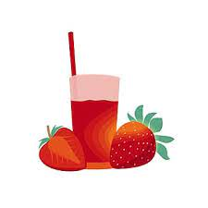 | 25. Today we will be making smoothies. | 26. We wil be creating our own beach towels. |  | 28. Today we will be making special gifts for our friends.
31. We will be having a watermelon themed day!

