Monday | Tuesday | Wednesday | Thursday | Friday
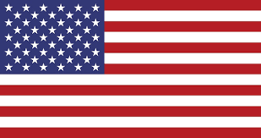 | 4. American Indepdence Day!  Lets make flags. | 5. Lets learn about the people who look after us. | 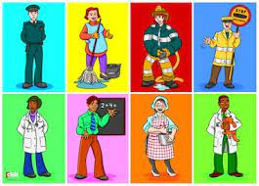 | 7. World Chocolate Day! Lets make our own krispie cakes.
10. Please do not forget your home observations from the weekend. | 11. Lets make a rainbow salad. | 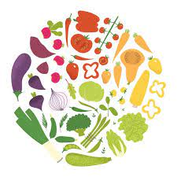 | 13. Let’s make silly soup in our water tray. | 14. Shark Awareness Day! Let’s draw our own shark.
17. World Emoji Day!  Lets explore feelings. | 18. Nelson Mandela Day. Today we will be drawing our own houses. | 19. We will be making rain shakers. | 20. Anniversary of the moon landing. Lets explore space | 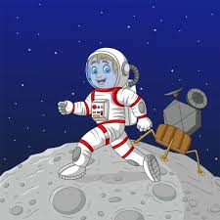
 | 25. Lets read the book All kinds of People. | 26. Lets draw self portraits. | 27. Lets make gingerbread men

