Monday | Tuesday | Wednesday | Thursday | Friday
3. We will be going on a treasure hunt to find different objects. | 4. Today we will be exploring different forms of transport. | 5. We will be having a beach theme day so please dress up in beach wear. | 6. We will be mark making in different textures | 7. We hope you have a lovely weekend. Please remember your home observations.
10. We will be having a picnic in the garden, we will be making our own sandwiches | 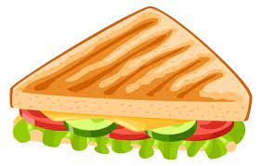 | 12. Lets explore different sounds. |  | 14. We will be having lots an ocean themed day!
17. Bring photos of what you have been up to on the weekend! | 18. Exploring different frozen vegetables | 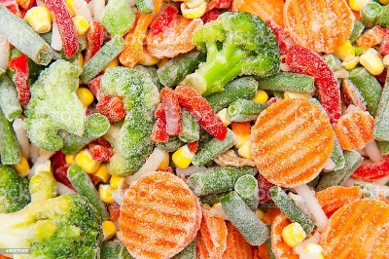 | 20. We will be exploring safari animals. | 21. Don’t forget to vote your GEM.
24. We will be exploring ice play. |  | 26. Lets make some delicious smoothies. |  | 28. Today we will be making handprint cards for our families
31. We will be making cheesecake for National Cheesecake day.

