Monday | Tuesday | Wednesday | Thursday | Friday
 | 1.Today we will be exploring different colours through coloured spaghetti. | 2. Today we will be having an ice cream sensory tray for World Ice cream Sandwich Day | 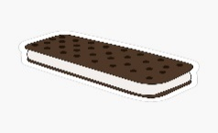 | 4. We will be looking at different butterflies and creating a butterfly cycle sensory tray.
7. We will be exploring different textures using different materials. | 8. Lets create our own owls. |  | 10. We will be making our own ice lollies. | 11 We will be exploring a beach themed sand tray.
14. We will be looking for minibeasts in the garden for Bug Day. | 15.Today we will be exploring flowers in water. | 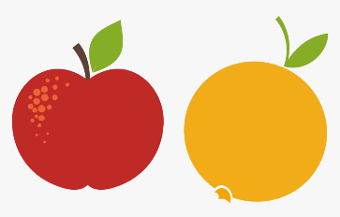 | 17. We will be tasting apples and oranges | 18. We hope you have a lovely weekend. Don’t forget your Home Observations.
21. We will be creating collages using leaves and tree bark. | 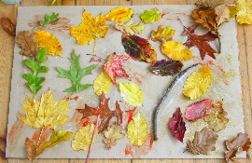 | 23. We will be creating different marks using fruits | 24. We will be making our own vegetable kebabs
28. Bank Holiday.  Nursery is closed today. Have a lovely day! | 29. We will be exploring herb scented playdough. | 30. Today we will be completing lots of different role play. | 31. We will be using the blocks to build towers.

