Monday | Tuesday | Wednesday | Thursday | Friday
 |  | 2. Today we will be making watermelon ice lollies. | 3. We will be having a watermelon themed day for National Watermelon Day!
7. We will be exploring our favourite stories. |  | 9. Story time  Stay and Play for National Book Lovers Day. 4:30-5:30pm. | 10. Come to nursery dressed in your pjyamas.
14. Lets make flower potions. | 15. We will be using flowers to make marks in paint. | 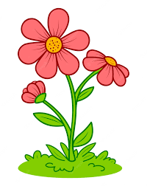 |  | 18. We will be making fajitas for National Fajita Day.
 | 22. Summer Stay and Play. 4-5pm. | 23. Don’t forget your Home Observations. | 24. Water painting in the garden. | 25. Lets explore frozen paint.
28. Bank Holiday. Nursery is closed today. Have a lovely day! | 29. What did you get up to this weekend? | 30. Lets make a sensory beach for National Beach Day!

