Monday | Tuesday | Wednesday | Thursday | Friday
 | 1. Please bring in your home observations. | 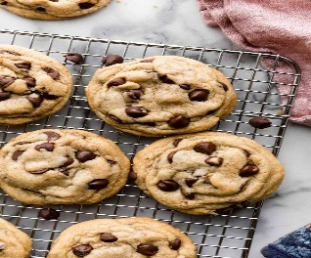 | 3. National Chocolate Chip Day. Lets make cookies. | 4. Today we will be learning about owls for National Owl Awareness Day.
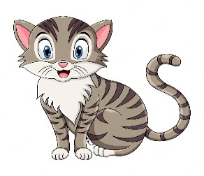 | 8. We will be having a cat themed day for National Cat Day! | 9. Rice Pudding Day!  Lets make rice pudding | 10. World Lion Day! Let’s create our own lion masks.
14. We will be looking for exploring different types of lizards. | 15. Lets read Monkey Puzzles. | 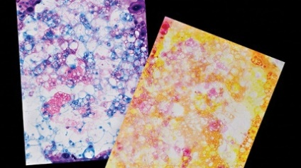 | 17. Today we will be bubble painting. | 18. We will be creating an orangutan and learning all about them.
21. Today we will be reading Hairy Mclary. |  | 23. Today we will be making our own lemonade crafts. | 24. International Bat Day. We will be creating a bat silhouette.
28. Bank Holiday. Nursery is closed today. Have a lovely day. | 29. Let’s create sea shells. | 30. Today we will be having a beach themed day! | 31. Lets make smoothies

