Monday | Tuesday | Wednesday | Thursday | Friday
 | 1. Today we will be making Yorkshire Puddings for National Yorkshire Pudding Day! | 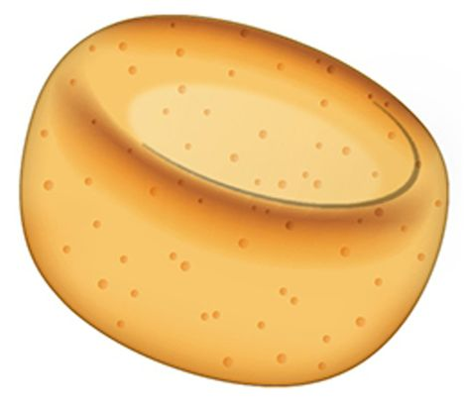 | 3. Today we will be creating our own treasure maps. | 4. Today is Owl Awareness Day! We will be making our own nests.
7. Today is Sea Serpent Day. Lets explore different serpents. | 8. We will be having a cat themed day! | 9. We will be making our own rice pudding for National Rice Pudding Day! | 10. We will be making our own lion masks.
14. Today we will be reading the story ‘The Rainbow Fish’. | 15. We will be making fish shaped pizzas. | 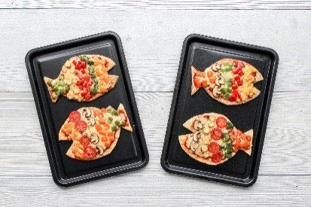 | 17. Lets decorate our own Rainbow Fish. | 18. We will be creating our own rock pool in our water tray.
21. We will be reading ‘The Leaf Man’ story. | 22. Lets create leaf rubbings. | 23. Today we will be making leaf shaped cookies. | 24. We will be making leaf shaped sun catchers. | 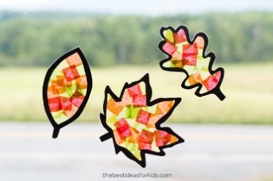
28. Bank Holiday. Nursery is closed today. Have a lovely day. |  | 30. Today we will be making our own pasta bracelets for Raksha Bandan. | 31. Lets paint daffodils for World Daffodil Day. | 